SUST 1134: Introduction to Sustainability Studies
Tuesday and Thursday from 12:30 P.M. to 1:45 P.M.
Mitchell Hall 211

Instructor: Thomas De Pree, Ph.D.
Office Hours: By appointment
E-mail: tadepree@salud.unm.edu

UNM Land Acknowledgement
Founded in 1889, the University of New Mexico sits on the traditional homelands of the Pueblo of Sandia. The original peoples of New Mexico – Pueblo, Navajo, and Apache – since time immemorial, have deep connections to the land and have made significant contributions to the broader community statewide. We honor the land itself and those who remain stewards of this land throughout the generations, and also acknowledge our committed relationship to Indigenous peoples. We gratefully recognize our history (see https://diverse.unm.edu/about-dei-at-unm/land-labor-acknowledgement.html).

Course Description
This course provides a broad survey of various aspects of sustainability. Students will explore topics such as climate change, renewable energy, water, agriculture, green building, socially responsible business, micro lending, environmental justice, smart growth and alternative progress indicators. Students will examine both contemporary challenges to sustainable development and examples of successful sustainability initiatives on local, national, and global levels.

Student Learning Outcomes
- Explain the concept of sustainability using the “3 E’s”—environmental health, social equity, and economic vitality.
- Describe examples of successful sustainability initiatives.
- Identify current environmental, social, and economic issues.
- Propose sustainable solutions to current problems by analyzing issues, recognizing multiple stakeholders, and evaluating likely outcomes.
- Apply course concepts and promote sustainability in the community.
- Understand and explain the importance of sustainable practices.
- Demonstrate an understanding of the scientific aspects of sustainability practices and issues.

Course Overview
- Reading Seminar and Group Activities (Tuesday): Our week will begin with about five minutes of “housekeeping” and checking in, followed by a short lecture (given by either the instructor or nominated students) that introduces and contextualizes the selected reading or the particular group activity (e.g., product lifecycle analysis, the implosion exercise, calculating carbon footprints, evaluating sustainable development goals), and open up group discussion and other activities. Prior to each seminar we will read various news media, essays, articles, book chapters, etc. (~30 pages per week). In addition to writing “annotations” (i.e., systematic notetaking) for your bibliographies, each student will write a 250-word response to a question posed weekly by the instructor. These written responses will be graded and used to measure literacy in sustainability studies (20% of final grade). Your responses to these writing prompts will also serve as the basis for our discussion on Tuesdays. The seminar is an important space to demonstrate your fluency in sustainability studies (20% of final grade) as you become conversant in this field of academic scholarship and active community engagement.

- Collaborative Case Study Research Projects (Thursday): Thursdays are dedicated to collaborative case study research. Students will be given class time to collaborate in groups and co-author one page (~500 words) in response to one of the 10 questions in the analytic framework provided on page four of this syllabus. Students are strongly encouraged to read each assigned case study question in advance and begin writing responses prior to meeting on Thursday. In the process of conducting case study research, students will articulate a sustainability goal associated with their cases, and write a 250-to-300-word abstract for a place-based sustainability project with measurable objectives and practical local engagements and activities. At the end of the course, students will give group presentations of their collaborative case study research projects. (Please bring your laptops, cell phones, and other digital devices to class on Thursdays.)

Supplemental Resources
- The Annotation Template provided below will help focus your note-taking as you read through each assigned text. Collect all of your reading annotations into a single Word Document that will be submitted along with your Collaborative Case Study Research Projects.
Annotation Template
- Enter the bibliographic citation into your notes for convenience and later incorporation in the annotated bibliography. For example:
York, Richard and Eugene A. Rosa. 2003. Key Challenges to Ecological Modernization Theory: Institutional Efficacy, Case Study Evidence, Units of Analysis, and the Pace of Eco-Efficiency. Organization and Environment 16(3):273-288.
- What is the main argument or thesis of the text?
- What evidence is presented to support their argument?
- What concepts or key terms are introduced to make sense of the data and support the argument?
- Do any of the key terms or concepts help you understand specific aspects of the case(s) you are studying? If so, how? If no, why not?
- Copy and paste three of the most important quotes from the text into your notes. Why did you select these as the most significant quotes?
- Ways of Reading: https://docs.google.com/spreadsheets/d/1-a6vX04NX3g4Q6bHyHd_LB4r58-x5_pZNspXbxSLi7s/edit#gid=0
- Public Meetings: Occasionally, there will be opportunities in the course to attend public meetings hosted by various federal, state, and tribal government agencies, and NGOs. These meetings will be directly related to the statewide student learning outcomes for sustainable studies. Attending public meetings is optional, but the information they provide will support your collaborative case study research projects. I will circulate the details of the meetings in advance by email. Please check your email frequently because some of the meetings will be scheduled with very short notice.
- Rubrics and Assessment: A rubric will be provided for the collaborative case study research project, and your sustainability goal(s) and abstract for a sustainability plan. The rubrics will serve as an instrument for measuring the student learning outcomes for this course.
- Collaborative Case Study Research Questions:
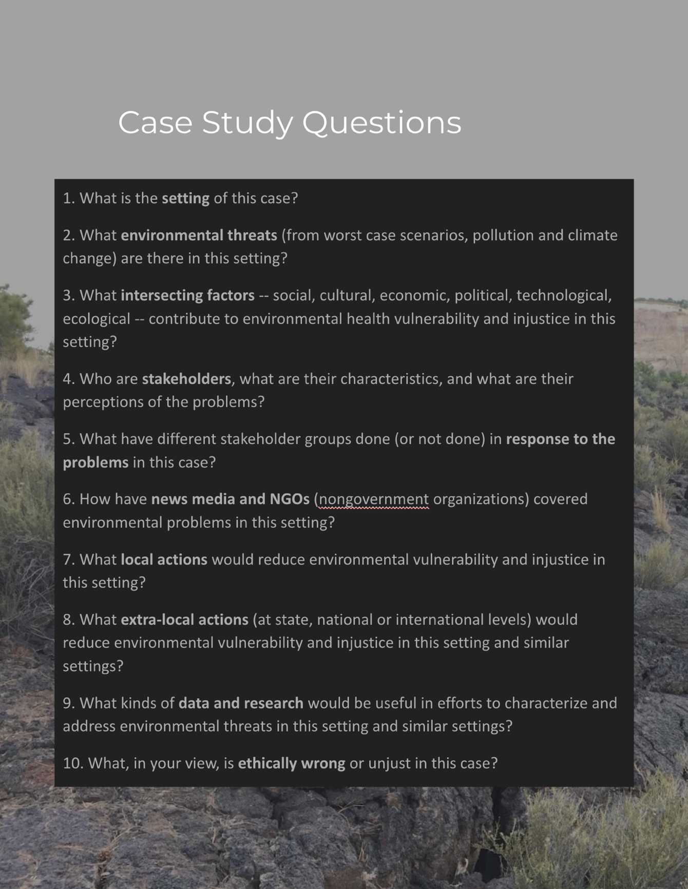

Finally, given what you learned in the course of your collaborative case study research, each group will articulate a community-based sustainability goal(s), and draft a 250-to-300-word abstract for a plan with measurable objectives and practical local engagements and activities.

Grading
- Annotated Bibliography 20% DUE April 30th
- Discussion Board Posts (Literacy) 20% DUE Every Tues.
- Engaging Class Discussions (Fluency) 20%
- Collaborative Case Study Research Project 40% DUE May 9th
& Sustainability Goal
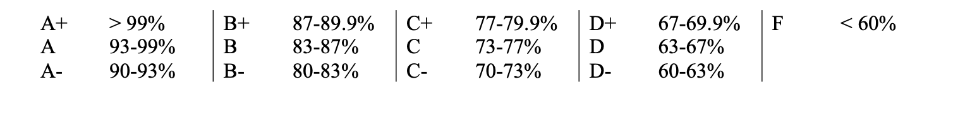Academic Integrity: At UNM, honesty is considered one of the cornerstones of academic development. There are policies in place to protect you and the academic community in doing the right thing; these are available in the Student Pathfinder as well as in the Faculty Handbook. These include policies on student grievances D175 (undergraduates), academic dishonesty (D100), and respectful campus (CO9). Please ask for help in understanding and avoiding plagiarism (passing the work or words of others off as your own work or words) or other forms of academic dishonesty. Doing something dishonest in a class or on an assignment can lead to serious academic consequences. Come talk with me about your concerns or needs for academic flexibility or talk with support staff at one of our student resource centers before you do something that may endanger your career.

Course Schedule

Week One
- Jan. 16 Introductions + Broad Overview of the Syllabus
- Overview of Course Literature + Annotated Bibliography + Seminar/Discussion Board
  - Ways of Reading: https://docs.google.com/spreadsheets/d/1-a6vX04NX3g4Q6bHyHd_LB4r58-x5_pZNspXbxSLi7s/edit#gid=0
- Jan. 18 Introduction to Collaborative Case Study Research Projects
  - Watch video: https://faculty.sites.uci.edu/kimfortun/2020/04/29/anthro25a-environmental-injustice/
  - View previous case studies: https://disaster-sts-network.org/content/eij-fall-2019-fast-disaster-case-study-stockton-group-13
  - The Atkore United Poly Systems Fire in ABQ, NM on Aug. 6.
    - https://sourcenm.com/2023/08/16/it-smelled-like-plastic-that-creates-a-memory/
    - https://www.washingtonpost.com/nation/2023/08/07/recycling-fire-albuquerque-alert/
    - https://www.abqjournal.com/multimedia/see-16-photos-as-fire-erupts-from-plant-near-mesa-del-sol/collection_c3b86aba-34b2-11ee-828c-8b95c74d3500.html#1
    - https://www.kob.com/new-mexico/crews-contain-fire-at-plastic-storage-facility-in-mesa-del-sol/
    - https://www.mirror.co.uk/news/us-news/breaking-albuquerque-fire-thick-black-30642908
    - https://www.krqe.com/news/albuquerque-metro/scene-cleared-after-fire-at-albuquerque-recycling-plant/
    - https://abcnews.go.com/Technology/plastic-building-recycling-centers-catching-fire/story?id=89125707

Module One: “Sustainability” and the “3 E’s”: Environmental Health, Social Equity, and Economic Vitality?

Week Two
- Jan. 23 What is Sustainability? What are the “3 E’s”?
  - Watch: https://www.sustain.ucla.edu/what-is-sustainability/
  - Environmental Health:
    - https://www.niehs.nih.gov/health/topics/science/index.cfm;
    - https://www.hsph.harvard.edu/c-change/news/fossil-fuel-air-pollution-responsible-for-1-in-5-deaths-worldwide/
    - https://sourcenm.com/2023/08/16/it-smelled-like-plastic-that-creates-a-memory/
  - Social Equity:
    - https://www.humanrightscareers.com/issues/what-is-social-equity/; https://www.instagram.com/reel/CwF88n9vpA8/?igshid=MTc4MmM1YmI2Ng%3D%3D; https://www.washingtonpost.com/climate-environment/2023/08/17/greenhouse-emissions-income-inequality/
  - Economic Vitality:
    - For example, US Federal sustainability plan (https://www.sustainability.gov/federalsustainabilityplan/)
    - Getting past the “jobs versus environment script” (e.g., history of EPA)
- Jan. 25 Select Cases and Form Research Groups
  - List potential place-based case studies for collaborative research
    - Valle de Oro (Rio Grande)
    - Red Water Pond Road Community (Puerco River);
    - Mount Taylor; San Mateo Creek Basin (Rio San José; San Andres-Glorieta aquifer);
    - Village of Paguate, Jackpile Mine (Rio Paguate)
    - Chupadera Mesa; Tularosa Basin Downwinders Consortium
    - Calf Canyon/Hermits Peak Fire (Gallinas River)
    - OTHER SUGGESTIONS??
  - Based on mutual research interests, students will form groups of about 3-4 individuals.

Week Three
- Jan 30 David Orr (2004), Earth in Mind
  - Introduction (pages 1-3);
  - What is Education For (pages 7-15);
  - Chapter Four: The Business of Education;
  - Chapter Seven: Reflections on Water and Oil (54-59);
  - Chapter Seventeen: Architecture as Pedagogy (112-116);
  - Chapter Eighteen: Agriculture and the Liberal Arts (117-121).
- Core concepts of sustainability studies: (1) green building; (2) socially responsible business; (3) micro lending; (4) smart growth; (5) alternative progress indicators; (6) product lifecycle analysis. (Students are welcome to nominate themselves to present in class on any of these concepts throughout the course.)
- Feb. 1 Collaborative Case Study Research Projects: Question #1 What is the setting?

Module Two: Climate Change

Week Four
- Feb. 6 Welcome to the Anthropocene
  - Listen: https://www.npr.org/2019/04/16/713829853/climate-change-is-greatest-challenge-humans-have-ever-faced-author-says;
  - Review these brief articles:
    - Naomi Oreskes (2004), The Scientific Consensus on Climate Change (http://www.jstor.org/stable/3839754).
    - https://www.scientificamerican.com/article/calling-our-times-the-anthropocene-epoch-matters-dearly-to-you/
    - https://www.economist.com/leaders/2011/05/26/welcome-to-the-anthropocene
- Feb. 8 Collaborative Case Study Research Projects: Question #2 What environmental threats (from worst case scenarios, pollution and climate change) are there in this setting?

Week Five
- Feb. 13 Compare and Contrast Sustainable Development Goals at a Municipal Scale
  - Review One/Plan NYC
    - https://onenyc.cityofnewyork.us/wp-content/uploads/2019/04/OneNYC-Strategic-Plan-2015.pdf
    - https://climate.cityofnewyork.us/initiatives/planyc-getting-sustainability-done/
  - Review ABQ CAP
    - https://www.cabq.gov/sustainability
    - https://www.cabq.gov/sustainability/climate-action-plan
- Feb. 15 Collaborative Case Study Research Projects: Question #3 What intersecting factors -- social, cultural, economic, political, technological, ecological -- contribute to environmental health vulnerability and injustice in this setting?

Module Three: “Clean” Energy

Week Six
- Feb. 20 Energy Sacrifice Zones + No False Solutions + Just Transitions
  - https://www.puebloactionalliance.org/blog/press-statement-indigenous-youth-frontline-grassroots-organizations-call-on-the-new-mexico-legislature-to-not-undermine-the-peoples-democracy-and-say-no-to-all-hydrogen
(Pueblo Alliance, Feb 7 2022).
- Feb. 22 Collaborative Case Study Research Projects: Question #4 Who are stakeholders, what are their characteristics, and what are their perceptions of the problems?

Week Seven
- Feb 27 Transitions: The Promises and Pitfalls of "Clean" Energy as Climate Mitigation
  - US Federal Sustainability Plan: https://www.sustainability.gov/federalsustainabilityplan/
  - UN SDGs: https://sdgs.un.org/goals
  - World Bank “mineral production to soar as demand for clean energy increases”: https://www.worldbank.org/en/news/press-release/2020/05/11/mineral-production-to-soar-as-demand-for-clean-energy-increases
- Feb. 29 Collaborative Case Study Research Projects: Question #5 What have different stakeholder groups done (or not done) in response to the problems in this case?

Module 4: Water

Week Eight
- Mar. 5 Barbara Rose Johnston, Shirley J. Fiske (2013), “The precarious state of the hydrosphere: why biocultural health matters” (https://doi.org/10.1002/wat2.1003).
- Mar. 7 Collaborative Case Study Research Projects: Question #6 How have news media and NGOs (nongovernment organizations) covered environmental problems in this setting?
Week Nine
- Mar. 12 Spring Break
- Mar. 14 Spring Break
Week Ten
- Mar. 19 Fred M. Phillips, G. Emlen Hall, Mary E. Black (2011), Reigning in the Rio Grande
- Mar. 21 Collaborative Case Study Research Projects: Question #7 What local actions would reduce environmental vulnerability and injustice in this setting?

Module Five: Nature/Culture, Agriculture/Wilderness, Urban/Rural
Week Eleven
- Mar. 26 Jake Kosek (2006), Understories: The Political Lives of Forests in Northern New Mexico (1-29)
- Mar. 28 Collaborative Case Study Research Projects: Question #8 What extra-local actions (at state, national or international levels) would reduce environmental vulnerability and injustice in this setting and similar settings?
Week Twelve
- Apr. 2 June Lorenzo (2017), Spatial Justice and Indigenous Peoples’ Protection of Sacred Places: Adding Indigenous Dimensions to the Conversation.
- Apr. 4 Collaborative Case Study Research Projects: Question #9 What kinds of data and research would be useful in efforts to characterize and address environmental threats in this setting and similar settings?

Module Six: Environmental Justice (EJ)

Week Thirteen
- Apr. 9 Mountain View Toxic Tour (field trip to Valle de Oro??):
  - https://www.youtube.com/watch?v=TjWNJ1o0IzM
  - https://nmelc.org/wp-content/uploads/2022/11/Health-Environment-and-Equity-Impacts-Reg-1-Pager.pdf
  - https://losjardinesinstitute.org/cumulative-impacts-%2F-heei
  - https://www.abqjournal.com/news/why-wont-city-council-address-industrial-air-pollution/article_984ede03-e13c-54d0-b58f-d7645c1e5421.html
  - Clifford Villa et al. (2020), Environmental Justice: Law, Policy, and Regulation (pages 3-38) (https://environmentaljusticebook.org/).
- Apr. 11 Collaborative Case Study Research Projects: Question #10 What, in your view, is ethically wrong or unjust in this case?
Week Fourteen
- Apr. 16 Guest Lecture from Teracita Keyanna (RWPRCA), Kirena Tsosie (SRIC), and Chris Shuey (SRIC): “Remembering the Church Rock Uranium Mill Tailings Spill and Imagining Possibilities for Restoring Indigenous Lands” under review in The Journal of Disaster Studies.
- Apr. 18 Collectively Write Sustainability Goal(s)

Module Seven: Traditional Ecological Knowledge (TEK)
Week Fifteen
- Apr. 23 Watch Kimmerer Lecture: http://indigenouseducation.org/multimedia/
  - Robin Wall Kimmerer (2013), Braiding Sweetgrass: Indigenous Wisdom, Scientific Knowledge, and the Teachings of Plants (pages 1-10).
- Apr. 25 Write Sustainability Objectives and Evaluation Plan
Week Sixteen
- Apr 30 Group Presentation of Case Study and Sustainability Goal
- May 2 Group Presentation of Case Study and Sustainability Goal
Week Seventeen
- May 7 Group Presentation of Case Study and Sustainability Goal
- May 9 Group Presentation of Case Study and Sustainability Goal
ACADEMIC SUPPORTS
Support in Receiving Help: Students who ask for help are successful students. I encourage students to be familiar with services and policies that can help them navigate UNM successfully. Many services exist to help you succeed academically. There are plenty of ways to find your place and your pack at UNM: see the “student guide” tab on my.unm, the “life help” link on students.unm.edu, the list of student services information, or ask me for information about the right resource center or person to contact.
Campus Resources: UNM is committed to providing courses that are inclusive and accessible for all participants. Extensive academic supports are there to assist students in achieving the academic success of which they are truly capable. Most students access these supports at some point in pursuit of their degree.
As your instructor, it is my objective to facilitate an accessible classroom setting, in which students have full access and opportunity. If you are experiencing any physical or academic barriers, or concerns related to mental health, physical health and/or COVID-19, please consult with me via email/phone or during student drop-in hours and I can direct you to the appropriate campus resources and services. I have also listed some commonly used resources below.
Accommodations: In accordance with University Policy 2310 and the Americans with Disabilities Act (ADA), academic accommodations may be made for any student who notifies the instructor of the need for an accommodation. It is imperative that you take the initiative to bring such needs to my attention, as I am not legally permitted to inquire. Students who may require assistance in emergency evacuations should contact the instructor as to the most appropriate procedures to follow. Contact Accessibility Resource Center at 505-277-3506 or arcsrvs@unm.edu for additional information.
Peer Tutoring: Center for Academic Program Support (CAPS) is an award-winning learning assistance program available to all UNM students enrolled in undergraduate classes. CAPS offers peer tutoring and academic support services for over 800 classes each semester. Students who work with CAPS typically do better in their coursework and graduate faster.
Mental Health and Counseling Services: All of us need a support system, and many students benefit from the use of counseling services. Numerous mental health resources exist on campus for students, including Student Health & Counseling (SHAC), which works with students to identify and address issues related to personal growth, self-confidence, anxiety, depression, eating disorders, academic difficulties, and career indecision. UNM Career Services can also provide assistance to students who are developing, evaluating, and/or implementing career, education, and employment decisions.
Hardship: Recent research shows that many students at UNM do not always have adequate food and housing (see the UNM Basic Needs Project website and report). These hardships create barriers to academic success, as well as physical and mental wellbeing. There are resources available on campus that can help, including the UNM Lobo Food Pantry, currently open by appointment as they move to their new location in the SUB; the Mobile Lobo Food Pantry, available on Tuesdays at 9:00am at EXPO NM (300 San Pedro Dr NE); UNM Federal CARES Act funds; and assistance with applying for SNAP benefits available through the Women’s Resource Center (WRC), available for all students, regardless of gender. These resources tend to be underutilized, so do not hesitate to take advantage of them and help raise awareness about them across campus. If financial or housing stress in any way prevents you from attending class or otherwise completing your work, please see me and I will work with you to help find ways to support you.
Title IX: Our classroom and our university should always be spaces of mutual respect, kindness, and support, without fear of discrimination, harassment, or violence. Should you ever need assistance or have concerns about incidents that violate this principle, please access the LoboRESPECT Advocacy Center and the support services listed on its website. Please note that, because UNM faculty, Teaching Assistants, and Graduate Assistants are considered “responsible employees” by the Department of Education, any disclosure of gender discrimination (including sexual harassment, sexual misconduct, and sexual violence) made to a faculty member, TA, or GA must be reported to the university's Title IX coordinator at the Office of Compliance, Ethics, and Equal Opportunity. For more information, see the campus policy regarding sexual misconduct.

The seminar can be thought of as a “book club,” which offers ample space to engage in unstructured and open-ended discussions about shared readings of mutual interest. Participants are expected to “engage” the literature, their peers, the instructor, and broader communities of practice on campus and off campus. Class “participation” tends to be a passive term in the context of learning. The requirement of “engaging” class discussions is active, and happens at a higher level of learning. I measure student engagement in the course by asking whether students are consistently interacting with other students and the course instructor in ways that are thoughtful, reflective, creative, critical and respectful. “Engagement” is more than talking; it is also listening, reflecting, and responding, verbally and non-verbally. Our interactions in this course are guided by principles of mutual reciprocity and honoring our relationships to each other, and our broader communities beyond the classroom.

